**Green Hydrogen Production:** **A Sustainable Energy Solution**

An Overview of Water Electrolysis Technologies

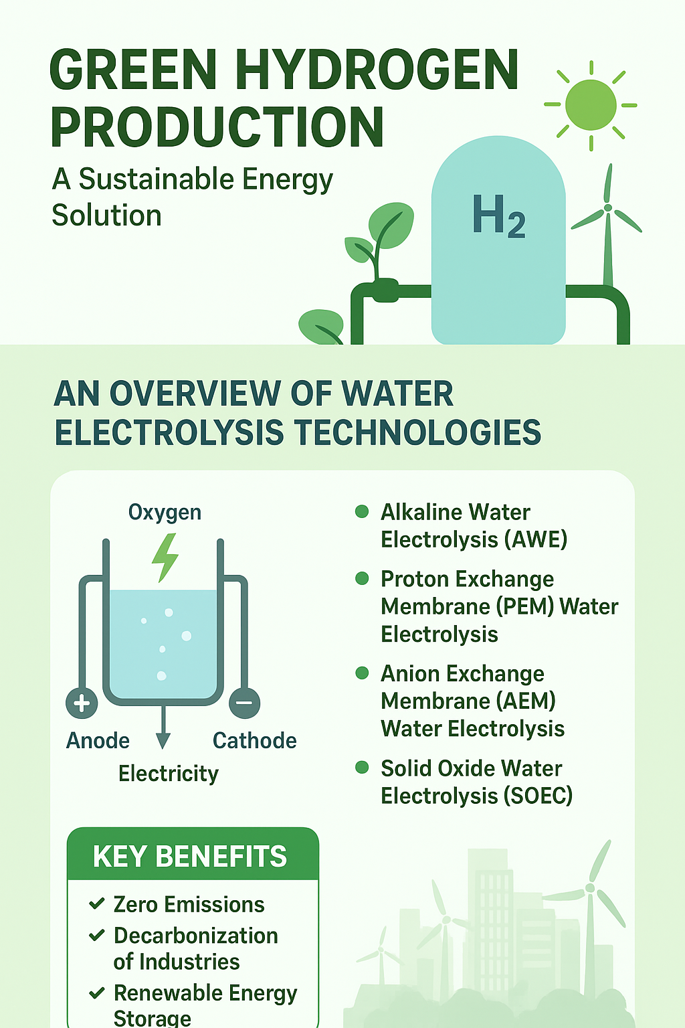

***Name: Pawan Kumar***

***Roll No. 220151010***

# **What is Green Hydrogen?**

* ***Definition:*** Green hydrogen is hydrogen gas produced by splitting water (H₂O) into hydrogen (H₂) and oxygen (O₂) through electrolysis.
* ***Key Feature:***The process is powered **exclusively by renewable energy sources** like solar and wind.
* ***Result:*** A **zero-emission fuel**, with water as the only byproduct.
* ***Impact:*** A critical solution for the global **decarbonization** of industry, power, and transportation sectors.

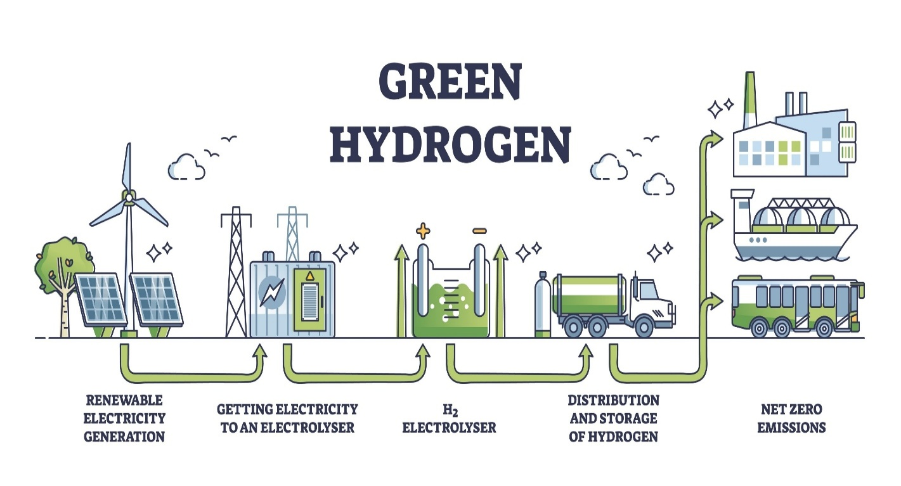

# **The Spectrum of Hydrogen Production:**

* Hydrogen is color-coded based on its production method:
* **Grey Hydrogen:**
  + **Source**: Fossil fuels (natural gas).
  + **Process:** Steam Methane Reforming.
  + **Impact:** High CO₂ emissions.
* **Blue Hydrogen:**
  + **Source:** Fossil fuels.
  + **Process:** Steam Methane Reforming with Carbon Capture and Storage (CCS).
  + **Impact:** Lower carbon footprint, but not zero-emission.
* **Green Hydrogen:**
  + **Source:** Water electrolysis.
  + **Process:** Powered by renewable energy.
  + **Impact:** No carbon emissions**.**

# **Renewable Sources for Green Hydrogen:**

* Clean energy is essential for producing green hydrogen.
  + **Solar Power:** Photovoltaic (PV) panels convert sunlight directly into electricity.
  + **Wind Power:** Wind turbines generate electricity from wind, effective in areas with consistent wind patterns.
  + **Hydropower:** Uses the force of flowing water to generate large amounts of stable electricity.
  + **Geothermal Energy:** Taps into the Earth's internal heat to produce a constant and reliable power supply.

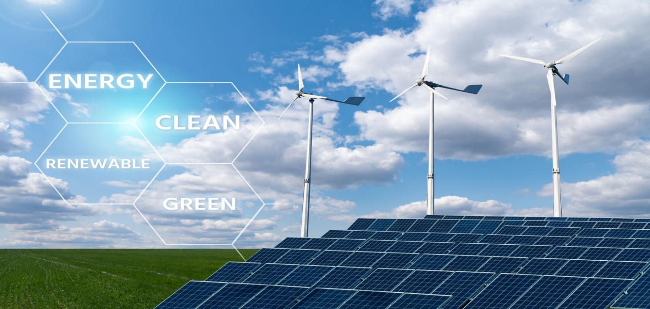

# **Electrolyzer Technology: AWE**

* **Alkaline Water Electrolysis (AWE)** is a mature and widely used technology.
  + **Working Principle:** Uses a liquid alkaline solution (e.g., KOH) as the electrolyte. Hydroxyl ions (OH⁻) travel through a porous diaphragm.
  + **Membrane:** A **porous diaphragm** separates the hydrogen and oxygen gases.
    - *Material:* Traditionally asbestos, now often advanced polymer composites.

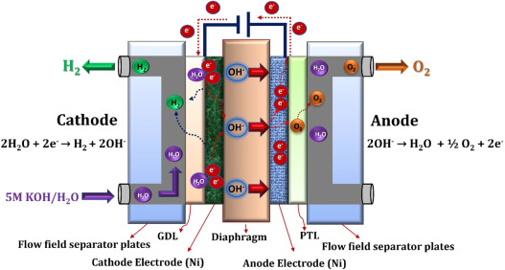

# **Electrolyzer Technology: PEM**

* **Proton Exchange Membrane (PEM) Water Electrolysis** is known for its high efficiency.
  + **Working Principle:** Water splits at the anode, and protons (H⁺) travel through a solid polymer membrane to the cathode.
  + **Membrane:** A **Proton Exchange Membrane**.
    - *Material:* Typically **Nafion** , a specialized polymer.

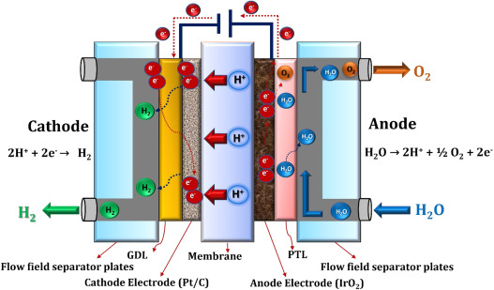

# **Electrolyzer Technology: AEM**

* **Anion Exchange Membrane (AEM) Water Electrolysis** is an emerging and promising technology.
  + **Working Principle:** Combines features of AWE and PEM. Hydroxyl ions (OH⁻) pass through a solid polymer membrane.
  + **Membrane:** An **Anion Exchange Membrane**.
    - *Material:* A solid polymer with positively charged functional groups.

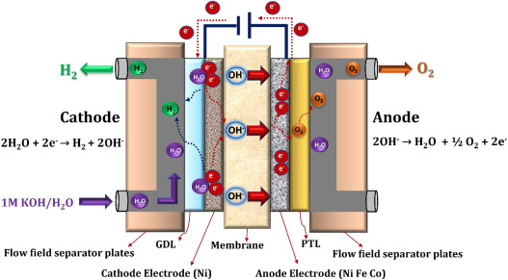

# **Electrolyzer Technology: SOEC**

* **Solid Oxide Water Electrolysis (SOEC)** operates at high temperatures for maximum efficiency.
  + **Working Principle:** Uses steam instead of liquid water. Oxide ions (O²⁻) are transported through a dense ceramic membrane.
  + **Membrane:** A **Solid Oxide Electrolyte**.
    - *Material:* A hard, dense ceramic material like **Yttria-Stabilized Zirconia (YSZ)**.

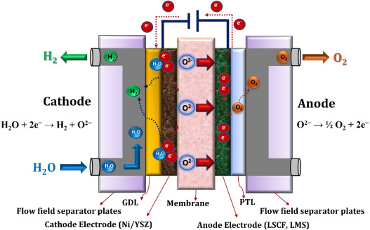

# **Technical Comparison of Water Electrolyzers:**

* ***Alkaline Water Electrolysis (AWE)***
  + **Operating State:** Liquid Water
  + **Electrolyte:** Liquid Alkaline (e.g., 25-30% KOH)
  + **Membrane/Separator:** Porous Diaphragm
  + **Ion Transported:** Hydroxyl (OH⁻)
  + **Catalyst Materials:** Non-Precious (e.g., Nickel)
  + **Operating Temp.:** 60 - 90°C
  + **Key Advantage:** Low-cost catalysts (Nickel), long operational lifetime.
  + **Key Challenge:** Lower current densities, use of corrosive liquid electrolytes.
* ***Proton Exchange Membrane (PEM) Electrolysis***
  + **Operating State:** Liquid Water
  + **Electrolyte:** Solid Acidic Polymer
  + **Membrane/Separator:** Proton Exchange Membrane (Nafion)
  + **Ion Transported:** Proton (H⁺)
  + **Catalyst Materials:** Precious Metals (Platinum, Iridium)
  + **Operating Temp.:** 50 - 80°C
  + **Key Advantage:** High purity hydrogen, compact design, quick response to power changes.
  + **Key Challenge:** Requires expensive precious metal catalysts (platinum, iridium).
* ***Anion Exchange Membrane (AEM) Electrolysis***
  + **Operating State:** Liquid Water
  + **Electrolyte:** Solid Alkaline Polymer
  + **Membrane/Separator:** Anion Exchange Membrane
  + **Ion Transported:** Hydroxyl (OH⁻)
  + **Catalyst Materials:** Non-Precious Metals.
  + **Operating Temp.:** 40 - 60°C
  + **Key Advantage:** Can use non-precious metal catalysts, operates with pure water.
  + **Key Challenge:** The long-term stability and durability of the membrane are still key research challenges.
* ***Solid Oxide Water Electrolysis (SOEC)***
  + **Operating State:** Steam (Gas)
  + **Electrolyte:** Solid Ceramic
  + **Membrane/Separator:** Dense Ceramic Electrolyte (YSZ)
  + **Ion Transported:** Oxide (O²⁻)
  + **Catalyst Materials:** Non-Precious Metals
  + **Operating Temp.:** 500 - 850°C
  + **Key Advantage:** **:** Very high energy efficiency, does not require precious metals.
  + **Key Challenge** Ensuring long-term stability and durability at high operating temperatures is challenging.

# **Applications of Hydrogen & Oxygen**

* The two products of water electrolysis are valuable commodities with a wide range of uses across multiple industries.

* ***Applications of Hydrogen (H₂) a versatile energy carrier and critical industrial feedstock.***
  + ***Fuel & Energy*:**
    - **Transportation:** Powers fuel cell electric vehicles (FCEVs), including cars, buses, and trucks, with water as the only emission.
    - **Power Generation:** Can be used in turbines or fuel cells to generate electricity, providing grid stability or off-grid power.
    - **Energy Storage:** Acts as a long-term storage solution for excess renewable energy from solar and wind.
  + ***Industrial Feedstock*:**
    - **Ammonia Production:** A primary component in the Haber-Bosch process to create ammonia for fertilizers.
    - **Petroleum Refining:** Used to process crude oil into refined fuels like gasoline and diesel by removing impurities.
    - **Methanol Production:** A key ingredient for producing methanol, which is used in chemical synthesis and as a fuel.
  + ***Other Uses*:**
    - **Metal Processing:** Used as a protective atmosphere in welding and annealing.
    - **Electronics:** Used in the manufacturing of semiconductors.
    - **Food Processing:** Used to hydrogenate oils to create margarines.
* ***Applications of Oxygen (O₂) the valuable co-product of electrolysis.***
  + ***Industrial Processes*:**
    - **Steel Manufacturing:** Essential for the basic oxygen steelmaking process to remove carbon impurities from iron.
    - **Chemical Production:** Used as an oxidant in the production of various chemicals, such as ethylene oxide.
  + ***Medical & Healthcare*:**
    - **Respiratory Therapy:** Administered to patients with breathing difficulties.
    - **Life Support:** Used in hospitals, ambulances, and for aviation and aerospace applications.
  + ***Other Uses*:**
    - **Wastewater Treatment:** Enhances the aerobic digestion process.
    - **Welding & Cutting:** Used with a fuel gas (like acetylene) to create high-temperature flames.

# **Conclusion & Key Challenges**

* **Conclusion:** Green hydrogen is a vital technology for a sustainable energy future, with various electrolyzer technologies offering different trade-offs.
* **Key Challenges:**
  + **Cost Reduction:** Lowering the cost of electrolyzers and renewable electricity.
  + **Durability & Efficiency:** Improving the performance and lifespan of all electrolyzer components.
  + **Infrastructure:** Building out the necessary storage and distribution networks for a global hydrogen economy.

# **References**

* National Grid. (2023, June 27). *What is green hydrogen and why do we need it?* [https://www.nationalgrid.com/stories/energy-explained/what-is-green-hydrogen](https://www.google.com/search?q=https://www.nationalgrid.com/stories/energy-explained/what-is-green-hydrogen)
* U.S. Department of Energy. (n.d.). *Hydrogen Production: Electrolysis*. Retrieved from <https://www.energy.gov/eere/fuelcells/hydrogen-production-electrolysis>
* <https://www.sciencedirect.com/science/article/pii/S2352484722020625>
* <https://www.sciencedirect.com/science/article/pii/S1364032123007992#sec3>